AIML SESSION 08 ASSIGNMENT SUBMISSION

Name of Student : Vaibhav Vijay Kate
Domain/Subject : AIML (Artificial Intelligence & Machine Learning)
College : Government Polytechnic College Washim
Branch : Information Technology
Session : 08

Q1
Q1. Creating Sets)
Write a program to create the following sets:
a) A set with 5 integers.
b) A set with mixed data types (integer, string, float).
c) An empty set using the correct method.
d) A set from the string "hello" using the set() constructor.
Print each set and its type. Add comments explaining why sets automatically
remove duplicates.

Program Code:
# a) A set with 5 integers.
set1 = {1, 2, 3, 4, 5}
print(type(set1), set1)
# b) A set with mixed data types (integer, string, float).
set2 = {1, "Vaibhav", 1.2}
print(type(set2), set2)
# c) An empty set using the correct method.
empty_set = set()
print(type(empty_set), empty_set)
# d) A set from the string "hello" using the set() constructor.
set4 = set("hello")
print(type(set4), set4)
# Sets automatically remove duplicates because a set stores only unique values.
# Example:
duplicate_set = {1, 2, 2, 3, 3, 4}
print(duplicate_set)

Output Screenshot: 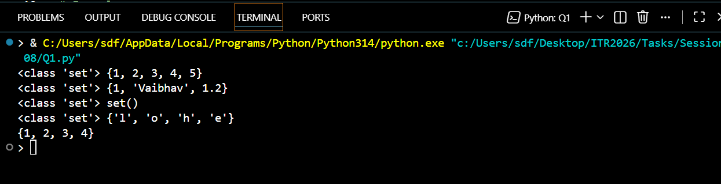

Q2
Q2. Characteristics of Sets)
Create a set: numbers = 10, 20, 30, 20, 40, 10, 50
Print the set and observe the output.
Demonstrate that sets are unordered by printing the set multiple times.
Try to access the first element using indexing (numbers[0 and explain the
error in comments.

Program Code:
# Create a set: numbers = {10, 20, 30, 20, 40, 10, 50}
numbers = {10, 20, 30, 20, 40, 10, 50}
# Print the set and observe the output.
print(numbers)
# Demonstrate that sets are unordered by printing the set multiple times.
print(numbers)
print(numbers)
print(numbers)
print(numbers)
print(numbers)
# Try to access the first element using indexing (numbers[0]) and explain the
# print(numbers[0])
# Reason:
# set are unordered that dosn't follow indexing
# That is numbers[0], numbers[1] indexing operations not allowed .

Output Screenshot: 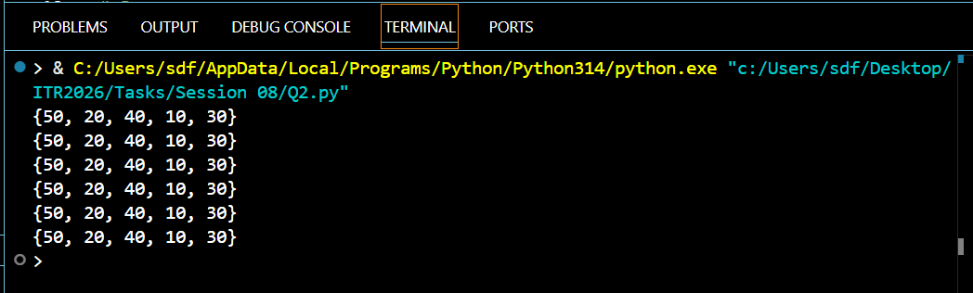

Q3
Q3. Membership Testing)
Write a program that:
Takes a set of 5 colors as input from the user.
Asks the user to enter a color name.
Checks whether the color is present in the set using in and not in.
Prints appropriate messages.

Program Code:
# (Membership Testing)
# Write a program that:
# Takes a set of 5 colors as input from the user.
# Asks the user to enter a color name.
# Checks whether the color is present in the set using in and not in.
# Prints appropriate messages.
# Takes a set of 5 colors as input from the user.
colors = set()
for i in range(5):
color = input("Enter a color: ")
colors.add(color)
# Asks the user to enter a color name.
search_color = input("Enter a color to search: ")
# Checks whether the color is present in the set using in and not in.
if search_color in colors:
print(f"'{search_color}' is present in the set.")
else:
print(f"'{search_color}' is not present in the set.")

Output Screenshot: 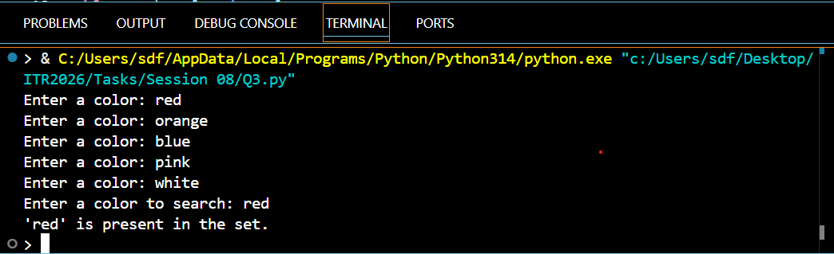

Q4
Q4. (add(), remove(), discard())
Create a set: fruits = {'apple', 'banana', 'mango'}
Perform the following operations and print the set after each step:
a) Add 'orange' using add().
b) Add 'banana' again (observe the result).
Session 08 (AIML) - Assignment Questions 1
c) Remove 'mango' using remove().
d) Try to remove 'grape' using discard() (no error should occur).

Program Code:
# Creating a Set
fruits = {'apple', 'banana', 'mango'}
# Perform the following operations and print the set after each step:
# a) Add 'orange' using add().
fruits.add('orange')
print(fruits)
# b) Add 'banana' again (observe the result).
fruits.add('banana')
# c) Remove 'mango' using remove().
fruits.remove('mango')
print(fruits)
# d) Try to remove 'grape' using discard() (no error should occur).
fruits.discard('grape')
print(fruits)

Output Screenshot: 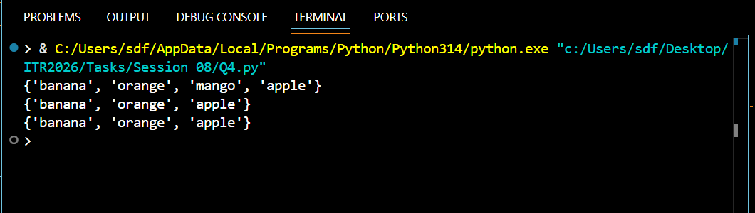

Q5
Q5. (pop() and clear())
Create a set: s = 100, 200, 300, 400, 500
Use pop() to remove and print one element.
Print the set after popping.
Clear the entire set using clear().
Print the final empty set.
Add comments explaining the difference between remove(), discard(), and pop().

Program Code:
# Creating a set
s = {100, 200, 300, 400, 500}
# Use pop() to remove and print one element.
removed_element = s.pop()
print("Removed element:", removed_element)
# Print the set after popping.
print("Set after pop :",s)
# Clear the entire set using clear().
s.clear()
# Print the final empty set.
print("Final set :",s)
# remove(x):
# Removes the specified element.
# Raises KeyError if the element is not found.
# discard(x):
# Removes the specified element.
# Does not raise an error if the element is not found.
# pop():
# removes an arbitrary element (sets have no indexing, so there is no "last" element).

Output Screenshot: 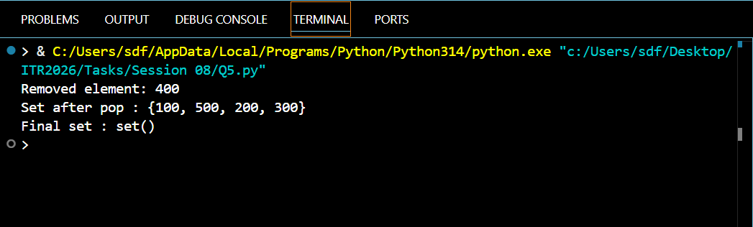

Q6
Q6. (update() and copy())
Create two sets:
set1 = 1, 2, 3
set2 = 3, 4, 5, 6
Make a copy of set1.
Update set1 with elements from set2 using update().
Print both the original copy and the updated set.

Program Code:
# Creating Sets
set1 = {1, 2, 3}
set2 = {3, 4, 5, 6}
# Copy of set1
c1 = set1.copy()
# Update set1 with set2
set1.update(set2)
# Print results
print("Original Copy:", c1)
print("Updated Set1:", set1)

Output Screenshot:
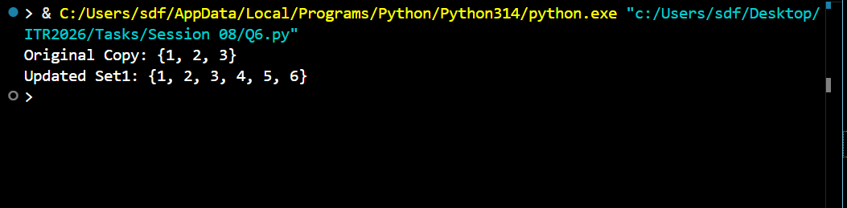

Q7
Q7. Union and Intersection)
Create two sets:
A = 1, 2, 3, 4, 5
B = 4, 5, 6, 7, 8
Print the union of A and B (using both .union() and operator).
Print the intersection of A and B (using both .intersection() and & operator).
Add comments explaining what each operation does.

Program Code:
# Creating Sets
A = {1, 2, 3, 4, 5}
B = {4, 5, 6, 7, 8}
# UNION
# Union combines all unique elements from both sets.
union1 = A.union(B)
union2 = A | B
print("Union using union():", union1)
print("Union using | operator:", union2)
# INTERSECTION
# Intersection returns only the common elements present in both sets.
intersection1 = A.intersection(B)
intersection2 = A & B
print("Intersection using intersection():", intersection1)
print("Intersection using & operator:", intersection2)

Output Screenshot: 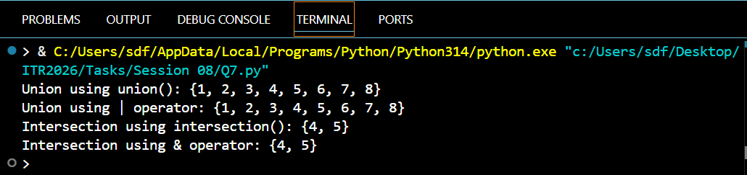

Q8
Q8. Combined Methods)
Write a program that:
Takes 6 numbers as input from the user and stores them in a set (duplicates
should be removed automatically).
Session 08 (AIML) - Assignment Questions 2
Adds two more numbers using add().
Removes one number safely using discard().
Prints the final set and its length using len().

Program Code:
# Taking 6 numbers as input and storing them in a set
s = set()
for i in range(6):
num = int(input("Enter number :"))
s.add(num) # Duplicates will be removed automatically
# Adding two more numbers
s.add(int(input("Enter first extra number: ")))
s.add(int(input("Enter second extra number: ")))
# Removing one number safely using discard()
remove_num = int(input("Enter a number to remove: "))
s.discard(remove_num)
# Printing final set and its length
print("Final Set:", s)
print("Length of Set:", len(s))

Output Screenshot: 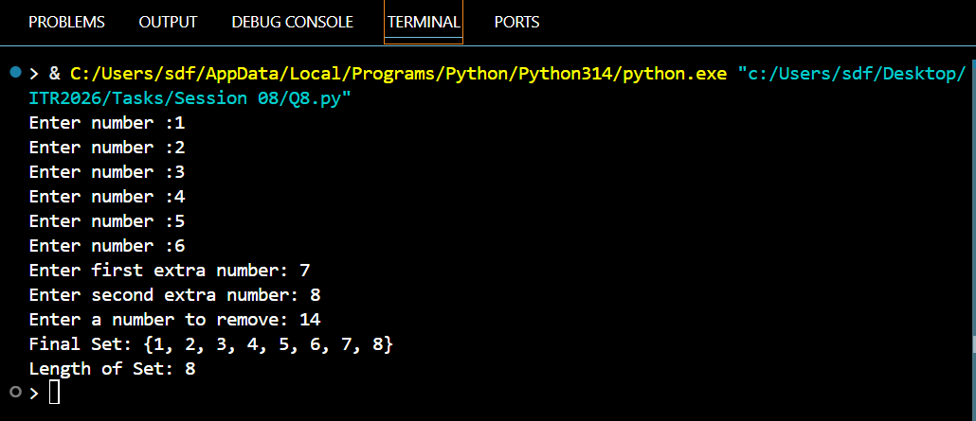

Q9
Q9. Practical Application)
Write a program to remove duplicate marks from a list of student scores using a
set:
scores = 85, 92, 78, 92, 85, 88, 95, 78
Convert the list to a set.
Print the unique scores.
Convert the set back to a sorted list and print it.
Print the total number of unique scores.

Program Code:
# Q9. (Practical Application)
# Original list of student scores
scores = [85, 92, 78, 92, 85, 88, 95, 78]
# Convert list to set (removes duplicates)
unique_scores = set(scores)
# Print unique scores
print("Unique Scores:", unique_scores)
# Convert set back to a sorted list
sorted_scores = sorted(unique_scores)
# Print sorted list
print("Sorted Unique Scores:", sorted_scores)
# Print total number of unique scores
print("Total Unique Scores:", len(unique_scores))

Output Screenshot: 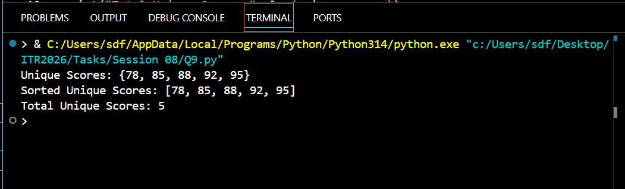

Q10
Q10. Mini Project - Combined Concepts)
Create a Unique Item Collector program using sets:
Repeatedly ask the user to enter items (e.g., favorite fruits, colors, or
numbers).
Store all entered items in a set (duplicates should be ignored).
Provide a menu with options:
Add item
Remove item (use discard)
Show all unique items
Check if an item exists
Clear all items
Exit
Use a while loop for the menu and appropriate set methods. Add meaningful
comments.
Session 08 (AIML) - Assignment Questions 3

Program Code:
# Unique Item Collector Program using Sets
# Empty set to store unique items
items = set()
while True:
# Display Menu
print("\nUnique Item Collector ")
print("1. Add Item")
print("2. Remove Item")
print("3. Show All Unique Items")
print("4. Check if an Item Exists")
print("5. Clear All Items")
print("6. Exit")
choice = input("Enter your choice (1-6): ")
# Option 1: Add Item
if choice == "1":
item = input("Enter item to add: ")
items.add(item)
print(f"'{item}' added successfully!")
# Option 2: Remove Item
elif choice == "2":
item = input("Enter item to remove: ")
items.discard(item) # Safe removal, no error if item doesn't exist
print(f"'{item}' removed (if it existed).")
# Option 3: Show All Unique Items
elif choice == "3":
if len(items) == 0:
print("No items available.")
else:
print("Unique Items:", items)
# Option 4: Check if an Item Exists
elif choice == "4":
item = input("Enter item to check: ")
if item in items:
print(f"'{item}' exists in the set.")
else:
print(f"'{item}' does not exist in the set.")
# Option 5: Clear AllItems
elif choice == "5":
items.clear()
print("All items have been cleared.")
# Option 6: Exit Program
elif choice == "6":
print("Exiting program.Goodbye!")
break
# Invalid Choice
else:
print("Invalid choice! Please enter a number between 1 and 6.")

Output Screenshot: 